233018
Abdul Basit
LAB4

Q1:
#include <stdio.h>
#include <unistd.h>

int globalVar =0;

int main()
{
pid_t pid1=fork();

if(pid1==0)
{
globalVar+=5;
printf("First Child : Global Value = %d\n",globalVar);
pid_t pid2=fork();
if(pid2==0)
{
globalVar+=5;
printf("Second Child : Global Value = %d\n",globalVar);
}
}
else
{
sleep(3);
printf("Parent : Global Var = %d\n",globalVar);
}
return 0;
}

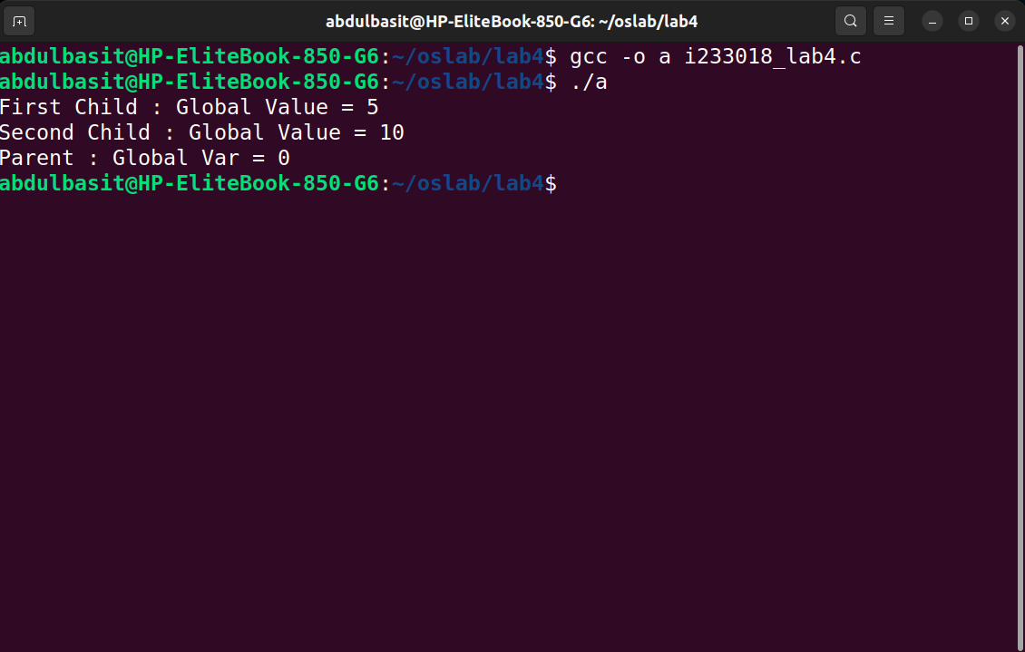
Q2:
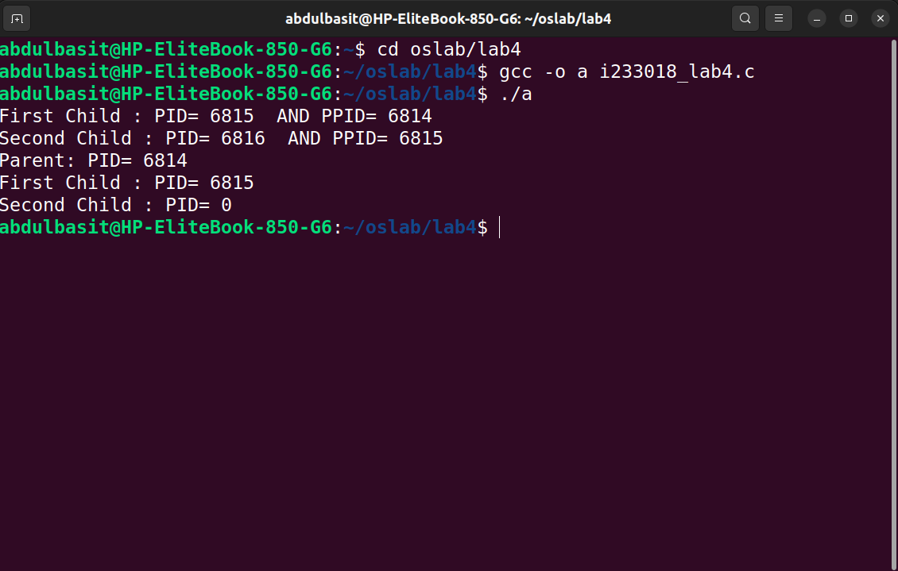

#include <stdio.h>
#include <unistd.h>

int main()
{
pid_t pid1=fork();

if(pid1==0)
{
printf("First Child : PID= %d AND PPID= %d\n",getpid(),getppid());
pid_t pid2=fork();
if(pid2==0)
{
printf("Second Child : PID= %d AND PPID= %d\n",getpid(),getppid());

}
}
else
{
sleep(1);
printf("Parent: PID= %d\n",getpid());
printf("First Child : PID= %d\n",pid1);
printf("Second Child : PID= %d\n",0);

}

return 0;
}

Q3:
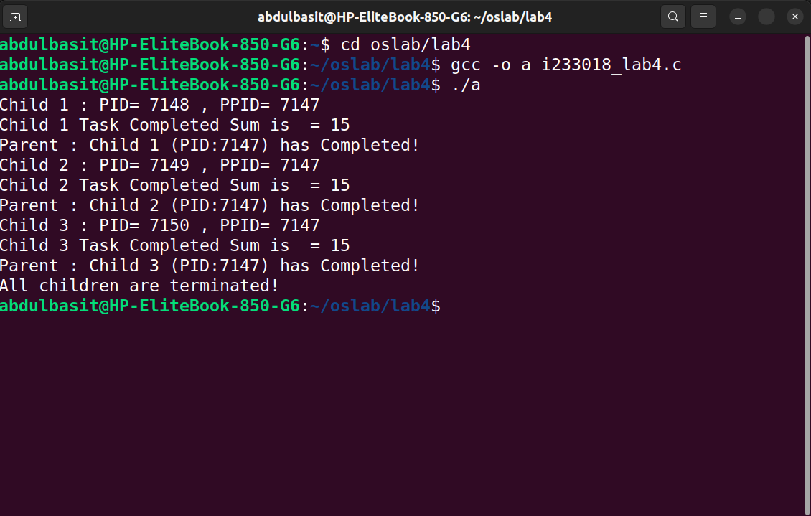
#include <stdio.h>
#include <unistd.h>
#include <stdlib.h>

int main()
{

for(int i=0;i<3;i++)
{
pid_t temp=fork();
int sum=1+2+3+4+5;
if(temp==0)
{
printf("Child %d : PID= %d , PPID= %d\n",i+1,getpid(),getppid());
printf("Child %d Task Completed Sum is = %d\n",i+1,sum);
exit(1);
}
else
{
sleep(1);
printf("Parent : Child %d (PID:%d) has Completed!\n",i+1,getpid());
}

}
printf("All children are terminated!\n");

return 0;
}

